**Chapter 6**

**Osteoarthritis Classification using**

**Convolutional Neural Network (CNN)**

**6.1 Introduction**

In This chapter the introduction of the applying of deep learning approach in term of the implementation of Convolutional Neural Network (CNN) for knee-OA detection and knee-OA stage classification are illustrated.

In term of OA classification study, the applying of deep learning approach to OA detection is illustrated in this section. As noted in Chapter 1 Section 1.3, the two studies were discussed (i) knee-OA detection study and (ii) knee-OA stage classification study. The major objective of knee-OA detection is to classify OA and normal, while knee-OA stage classification is focused on the stage of knee-OA classifying in case of 128 medical X-ray images presented. The fundamental idea of this section is illustrated the nature of each Whole knee and knee joint space X-ray image, using deep learning algorithm. In term of training data or pre-train model, the Convolutional Neural Network which is the deep learning algorithm of transfer learning technique present of the dataset segmentation as whole knee segmentation and knee joint space segmentation. This training can then be applied the AlexNet to build classifier that can be used to analyses OA classifying of image according to the nature of proposed .

More specifically, the deep learning approach of transfer learning technique is discussed where by the whole knee and knee joint space sub-image are presented using the CNN, both whole knee and joint space sub-image mentioned in Chapter 3 Section 3.4. To get the joint space more clear for the study, the Otsu’s algorithm was applied to knee joint space sub-image. Therefore, there three sub-set dataset were applied for study. Once each set of sub-image has been segmented the next stage of the data preparation phase is to consider as the input layer which the input layer was processed in the hidden layer then produce as the output layer for the classification result. The CNN was applied in the feature learning of the transfer learning process to remove the feature selection process. The major idea of the study is to adopt the transfer learning technique, especially a Convolutional Neural Network. In case of medical image, in work [77] have been applied CNN for Carotid intima-media thickness (CIMT) test detection. In order to deal with the study purpose, the CNN was applied to the AlexNet layer to learning the object feature in order to detect knee OA. A proposed framework of transfer learning is presented in Figure 6.1bellow:

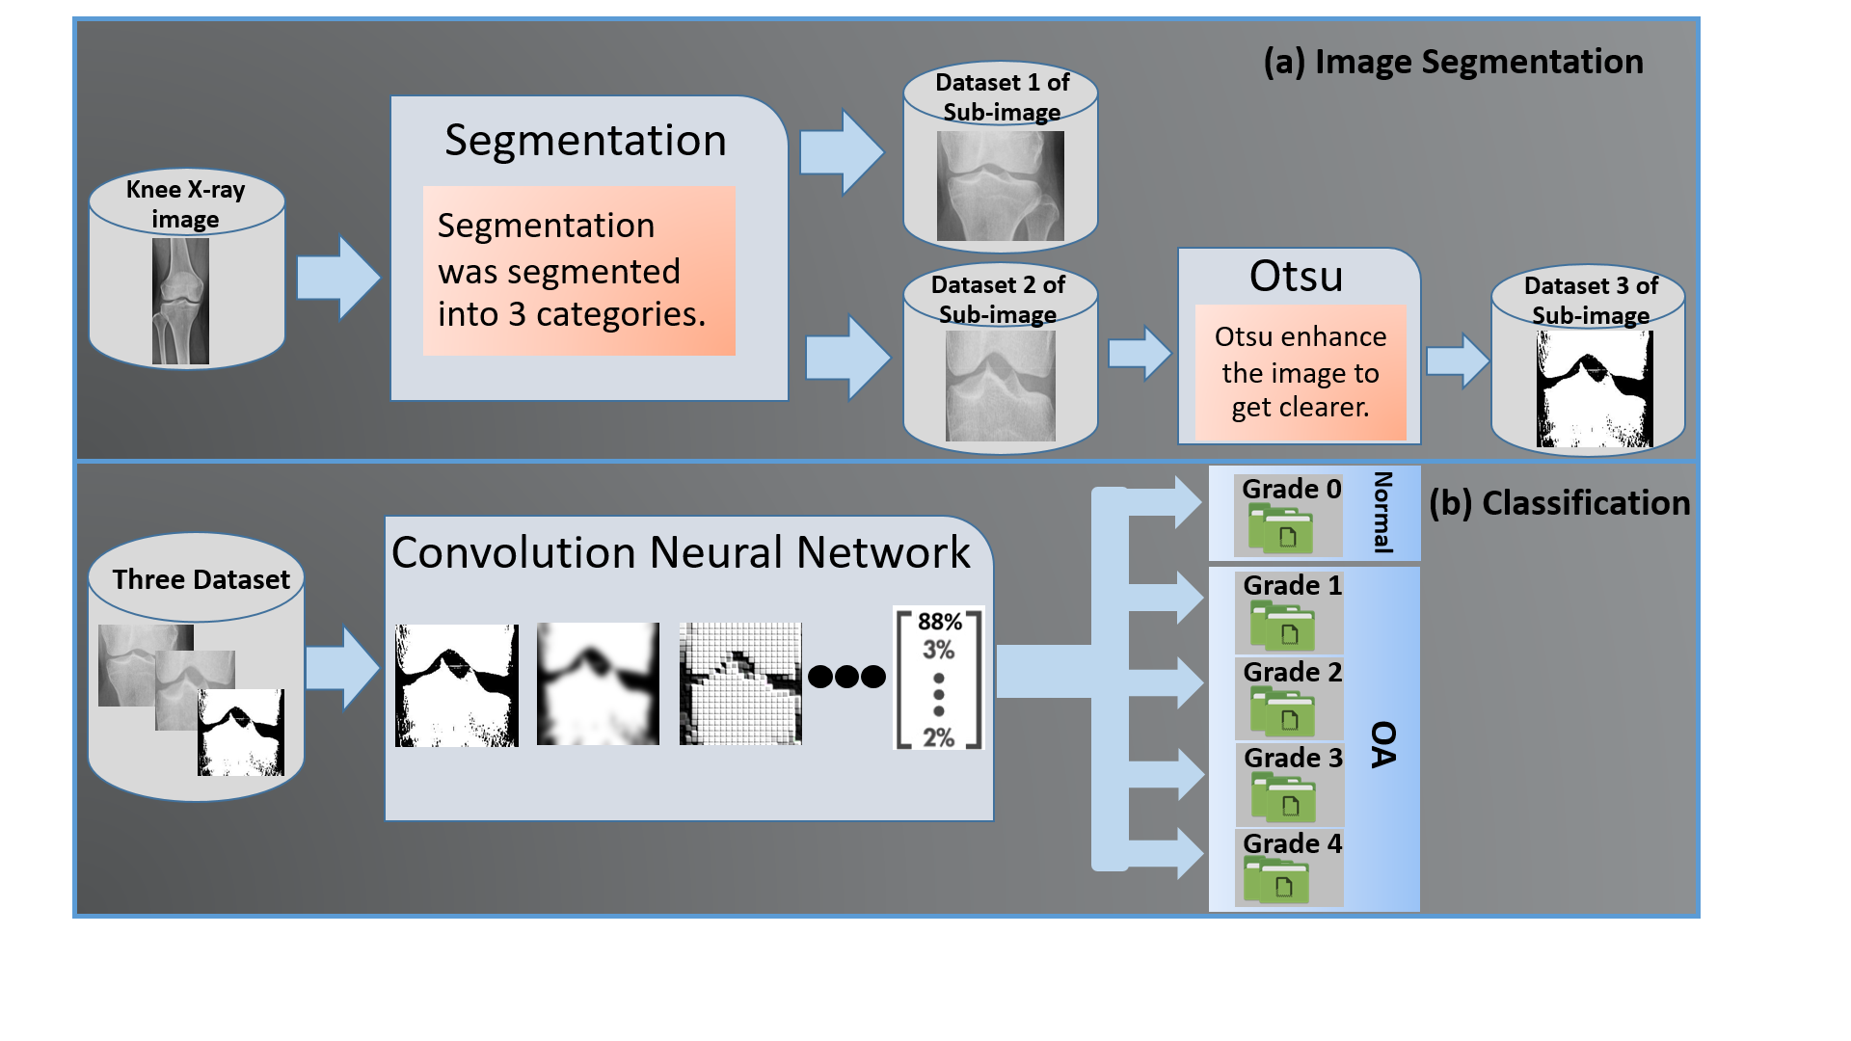

Figure 6.1 The framework OA detection by Applying CNN

From the Figure 6.1, it illustrated that transfer learning based of OA detection comprised of two main processes: (a) Image segmentation and (b) Classification process. For the process of image segmentation considered that include some the Otsu’s algorithm for the knee joint space subimage, as the first process of the framework was presented in Chapter 3 and will thus not be considered more in this chapter. In this study, there are three sub-image dataset that got from the segmentation and enhancement process: (i) the whole knee sub-image considered as the Dataset 1, (ii) the joint space sub-image considered as the Dataset 2, and (iii) the enhancement of joint space sub-image (Otsu implementation) considered as the Dataset 3. Once a dataset of each sub-image has been segmented, the next process refer to transfer learning process with AlexNet the input data of image need to be resize to 227x227 pixel for each image dataset, which used to learn the image feature in order to understand each image feature of normal image and knee OA image that can be suitable for image classification.

In the classification process mentioned of CNN application in Figure 6.1 contained a number of sub-processes. The major idea of the processing is to apply the CNN of transfer learning approach which is used the AlexNet layer to each sub-image dataset. In this case, the CNN of AlexNet can make the process of learning feature which can be applied with the reference to a classification model. The sub-process that create the classification process are comprised of three sub-processes: (i) input of each dataset or input layer, (ii) learning feature of each dataset or hidden layer, and (iii) the classification or output layer. To be consider that with the respect to figure 6.1 is in generic in nature and, as will be seen later in the next section in this chapter for OA stages detection.

The rest of this chapter is organized as follow: the information of convolutional neural network with transfer learning is presented in Section 6.2. The evaluation of the studies are illustrated in Section 6.3 that Sub-section 6.3.1 illustrates the knee-OA detection evaluation and Sub-section 6.3.2 presents the evaluation of knee-OA stage classification study. The discussion of OA classification studies are presented in Section 6.4. Finally, the summary of the OA classification studies are presented in Section 6.5.

**6.2 Convolutional Neural Network with AlexNet Transfer Learning**

Deep learning is considers as one of the most famous algorithm of machine learning algorithm which have been apply multi levels of learning. Deep learning is a technique developed from the artificial neural network which was inspired from human brain neurons connected system. Deep learning has been developed so far in computer vision technology including: image classification, object detection, and image segmentation. Depp learning model has had wiled development for various type of objection, the well-known deep learning model include (i) Autoencoder (AE), (ii) Deep Belief Learning (DBN), (iii) Convolutional Neural Network (CNN), and Recurrent Neural Network (RNN) [78]. With the respect to the study purpose, the convolutional neural network is discussed.

Convolutional neural network (CNN or ConvNet) has been considered as the one of the most popular model for deep learning. CNN model is directly uses for identification and classification tasks of image, video, text, or sound. With the CNN application, the CNN directly used to find the patterns in image. Thus, CNN use the pattern that they learn from image data to classify image and in CNN work the manual feature extraction is removed from the application. There are three factor that make CNN widely used in deep learning for classification task, include: (i) the manual feature extraction is remove when applied with CNN, mean that CNN learn directly to the image feature, (ii) the state-of-art recognition result is produced by CNN, and (iii) When a new recognition task come, the CNN can be retrained and enabling to create on pre-existing network. CNN is like other deep learning model, it consist of three important layers: (i) Input layer, (ii) Hidden layer, and (iii) Output layer. The Figure 6.2 illustrates the three layer of CNN deep learning model:

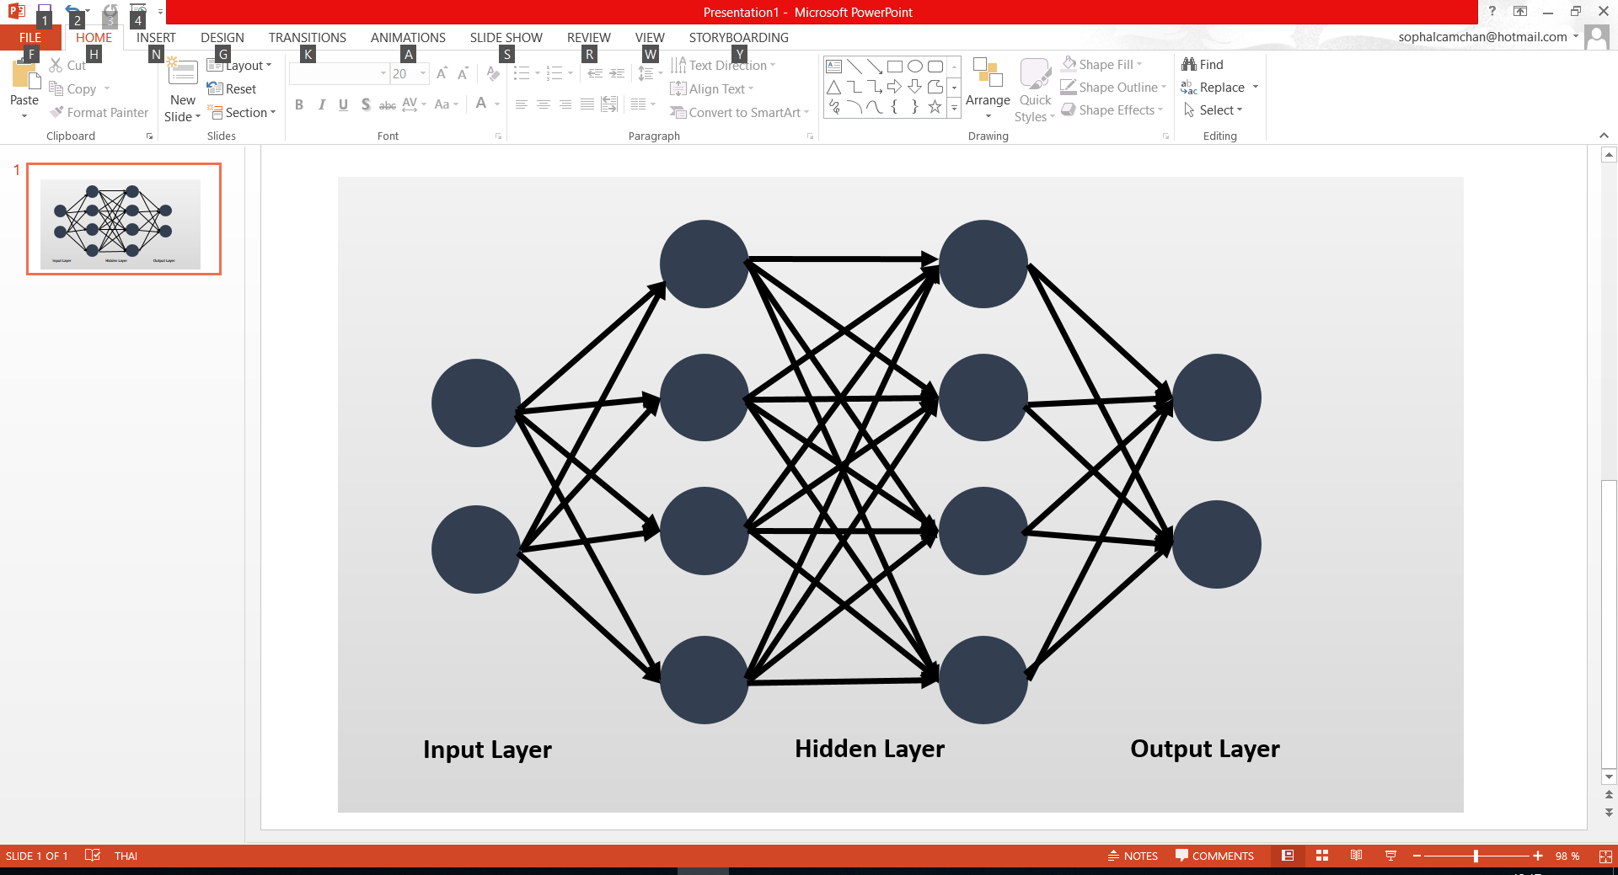

Figure 6.2: Three Layers of CNN Deep Learning Model

With the reference to Figure 6.2, these three layer can be operate in to the intent of learning feature. In the learning feature process, CNN use the most three common layers: (i) Convolution, (ii) activation or Rectified linear unit (ReLU), and (iii) Polling. Each of these three layer are mentioned in the following point:

* **Convolution:** in this layer, the input was brought through a group of convolution filters that can activate certain image feature.
* **ReLU:** in this layer, the maintaining positive value and mapping of negative value to zero is presented in order to produce the faster performance and more effective training. In this layer, only the activated features are selected and bring into the next layer that sometime called as activation.
* **Pooling:** in this layer, the number of parameter was reduced that the network need to learn this can be call the output of nonlinear downsampling.

CNN application can be learn from creating or building the CNN from scratch or use the pretrained model with study dataset. With the respect to the study, the pretrained model has been applied. AlexNet is the pertained model was introduced in the knee OA detection. AleNet is the CNN pretrained model that has been trained on 1.2 million high resolution image from the ImageNet LSVRC-2010 dataset [79]. The AlexNet model comprises of 23 layers and can be classified 1000 different categories (eg: head, knee, vehicle, cat, dog and etc.). AlexNet contained of 60 million parameters, five convolutional layers, in some of convolutional layer followed by max-pooling layers and three fully connected layers consists of 1000-way sofmax that can separated 1000 different image groups [79]. AlexNet pretrained layers are presented in the following, which layer 1 refers to the input image, and layer 25 is the classification layer. Thus, there are only 23 layers for AlaxNet pre-trained network:

|  |  |
| --- | --- |
| **Layer** | **Description** |
| 1 'conv1' Convolution | 96 11x11x3 convolutions with stride [4 4] and padding [0 0] |
| 2 'relu1' ReLU | ReLU |
| 3 'norm1' Cross Channel Normalization | cross channel normalization with 5 channels per element |
| 4 'pool1' Max Pooling | 3x3 max pooling with stride [2 2] and padding [0 0] |
| 5 'conv2' Convolution | 256 5x5x48 convolutions with stride [1 1] and padding [2 2] |
| 6 'relu2' ReLU | ReLU |
| 7 'norm2' Cross Channel Normalization | cross channel normalization with 5 channels per element |
| 8 'pool2' Max Pooling | 3x3 max pooling with stride [2 2] and padding [0 0] |
| 9 'conv3' Convolution | 384 3x3x256 convolutions with stride [1 1] and padding [1 1] |
| 10 'relu3' ReLU | ReLU |
| 11 'conv4' Convolution | 384 3x3x192 convolutions with stride [1 1] and padding [1 1] |
| 12 'relu4' ReLU | ReLU |
| 13 'conv5' Convolution | 256 3x3x192 convolutions with stride [1 1] and padding [1 1] |
| 14 'relu5' ReLU | ReLU |
| 15 'pool5' Max Pooling | 3x3 max pooling with stride [2 2] and padding [0 0] |
| 16 'fc6' Fully Connected | 4096 fully connected layer |
| 17 'relu6' ReLU | ReLU |
| 18 'drop6' Dropout | 50% dropout |
| 29 'fc7' Fully Connected | 4096 fully connected layer |
| 20 'relu7' ReLU | ReLU |
| 21 'drop7' Dropout | 50% dropout |
| 22 ' ' Fully Connected | 5 fully connected layer |
| 23 'prob' Softmax | softmax |

Table 6.1 The 23 Layer of Alex Pre-trained Network

As noted in Chapter 1 Section 13 the OA classification study comprised of knee-OA detection and knee-OA stage classification. Thus, AlexNet have been applied with the 128 medical X-ray images OA classification studies. The CNN Alex pretrained of knee X-ray image process is illustrated in Figure 6.3:

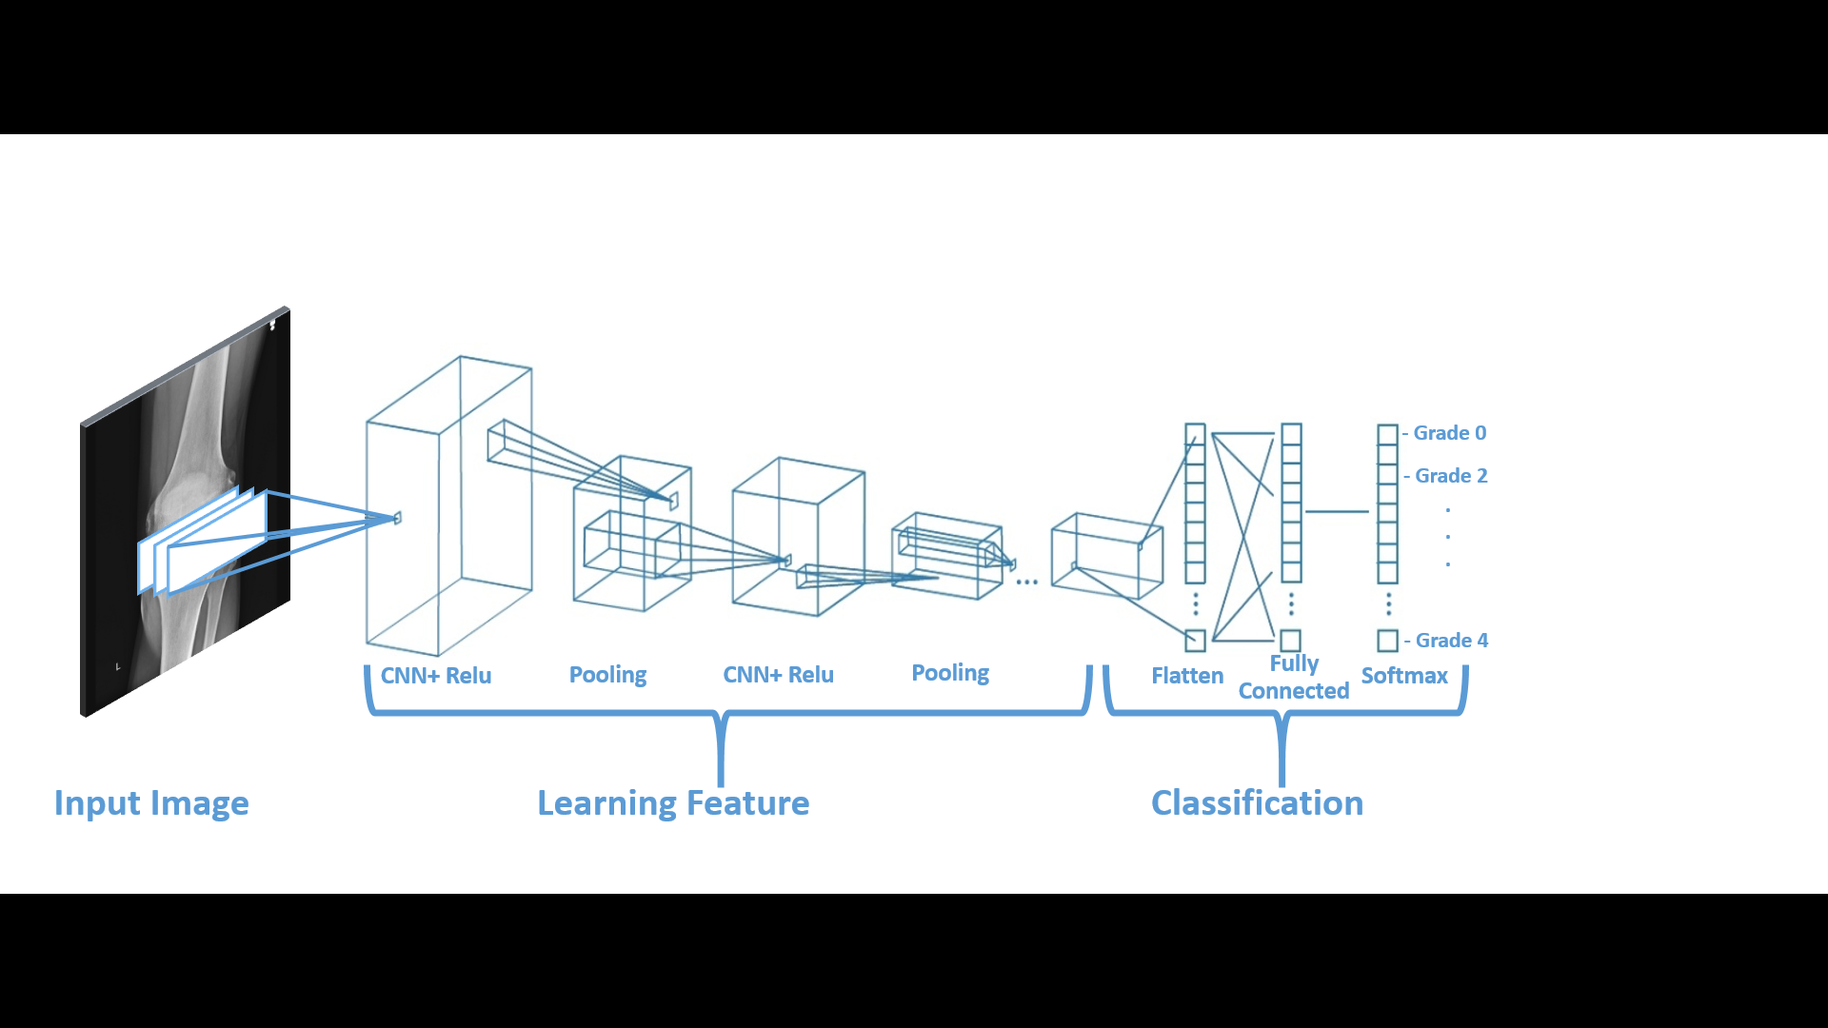

Figure 6.3 The example of CNN with many convolutional layers applied to Knee X-ray Imageries.

In the Figure 6.3 illustrated that the input of image have to be 227x277 square image size, then CNN was applied to learning the feature identify the different image features. After the learning feature that has contain of most three common layers mentioned above, finished in many layers, the architecture of CNN go forward to classification step. In the classification step, the next-to-last layer of classification is the fully connected layer that produce the vector of K dimensions where K is number of classes that network cab be predict as the probability value. The last layers of classification is defined by softmax, this final layer of CNN uses to provide the classification output.

Transfer learning is the commonly applying of deep learning application. In this study, the transfer learning of knee OA detection applied with AlexNet is discussed. In transfer learning, the pretrained network can take whenever the new classification task begin. Transfer learning work quickly and better performance of small image dataset. The Figure 6.4 illustrated the transfer learning mechanism of the study.

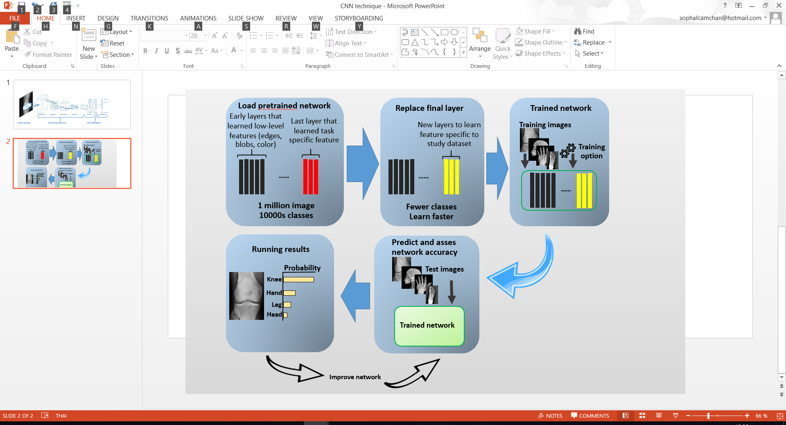

Figure 6.4: The example of transfer learning to four classes of medical image

From figure 6.4, it can be seen that the process of transfer learning with AlexNet pretrained model. The first process is the applied of AlexNet which has 1 million image to apply the new task of medical image classification, then the second process is the new layer which uses to learn to specific to image dataset. Next, the trained network which is taking a long time of the transfer learning process can be identify image feature foe build the feature vector, then the predict and asses network accuracy has been applied to each image. As a result, the image will be classified as the probability value. The knee OA detection has been applied the same schematic in Figure 6.4. Lastly, the evaluation of knee-OA detection and knee-OA stage classification apply with transfer learning is presented in Section 6.3 as follow.

**6.3 Evaluation**

**6.3.1 Osteoarthritis Detection using CNN**

For knee-OA detection using CNN is presented here, the evaluation of the transfer learning with AlexNet to detect knee OA is presented in this sub-section. Once, with the three different sub-image dataset have been applied to the study include: (i) Algorithm 1 subimage (the image of whole knee segmented image), (ii) Algorithm 2 subimage (the knee joint space segmented image), and (iii) Algorithm 3 subimage (the implementation of Otsu’s method to algorithm 2 subimage). As a result, the result of transfer learning all the algorithm subimage to knee OA detection study with the value of accuracy of 0.88 (Algorithm 1: AC =0.88, Algorithm 2: AC= 0.88, Algorithm 3: AC= 0.88).

6.3.2 Osteoarthritis Stage Classification using CNN

The evaluation of the transfer learning with AlexNet model to knee-OA stage classification study is presented in this sub-section. With the respect to the three different sub-image dataset have been applied to the study include: (i) Algorithm 1 subimage (the image of whole knee segmented image), (ii) Algorithm 2 subimage (the knee joint space segmented image), and (iii) Algorithm 3 subimage (the implementation of Otsu’s method to algorithm 2 subimage). As a result, the result of transfer learning all the algorithm subimage to knee OA detection illustrated in Table 5.2 below:

|  |  |
| --- | --- |
| Subimage | Accuracy |
| Algorithm 1 | 0.5185 |
| Algorithm 2 | 0.4444 |
| Algorithm 3 | 0.6296 |

Table 5.2 The Predicted Result of Knee OA Stages classification Study

From table 5.2 illustrated that the Algorithm 2 subimage (the application of Otsus method to knee joint space segmented image) produced the best predicted accuracy of knee OA stage classification with value of accuracy of 0.6296. For the Algorithm 1 subimage (the whole knee segmented image) produced the best predicted result with the accuracy value of 0.5185. It can be suggested that the knee clear joint space create a well perform of classification of knee OA stages with transfer learning AlexNet model.

**6.4 Discussion**

In this section the discussion of knee-OA classification is presented, the CNN deep learning mechanism with AlexNet pre-trained medel of transfer learning on OA detection and OA stage classification were considered in this chapter. With the respect to the discussion of Section 4.2 and Section 4.3, the main findings of chapter illustrated that for all three subimage of training dataset are well predicted in case of knee OA detection study, while knee OA stages classification study are well performance by Algorithm 3 subimage (the clear joint space subimage which applied Otsu’s method), followed by the Algorithm 1 subimage (the whole knee segmented image).

**6.5 Summary**

In short, the chapter presented the CNN deep learning model with AlexNet transfer learning on knee OA detection and knee OA stages detection study. Thus, in the chapter mainly focused two study approach: (i) OA detection and (ii) OA stages detection. For OA detection study base on transfer learning with AlexNet was illustrated in Section 5.2 and OA stages detection was pictured in Section 5.3. Base on the reported of each section shown that: for all three subimage were well produced for knee OA detection, while the Algorithm 3 subimage dataset was well produce for knee OA stages classification study.